**Database Management Systems**

A Database is a collection of records. Database management systems are designed as the means of managing all the records. Database Management is a software system that uses a standard method and running queries with some of them designed for the oversight and proper control of databases.

**Types of Database Management Systems:**

There are four structural types of database management systems:

* Hierarchical databases.
* Network databases.
* Relational databases.
* Object-oriented databases

**Hierarchical Databases (DBMS) :**  
In the Hierarchical Database Model we have to learn about the databases. It is very fast and simple. In a hierarchical database, records contain information about there groups of parent/child relationships, just like as  a tree structure. The structure implies that a record can have also a repeating information. In this structure Data follows a series of records, It is a set of field values attached to it. It collects all  records together as a record type. These record types are the equivalent of tables in the relational model, and with the individual records being the equivalent of rows. To create links between these record types, the hierarchical model uses these type Relationships.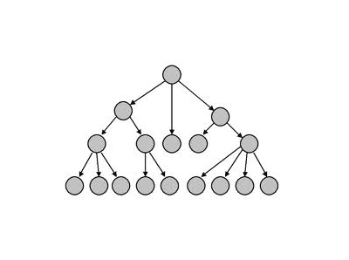             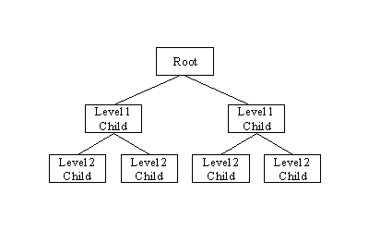  
**Advantage :** Hierarchical database can be accessed and updated rapidly because in this model structure is like as a tree and the relationships between records are defined in advance. This feature is a two-edged.

**Disadvantage :**This type of database structure is that each child in the tree may have only one parent, and relationships or linkages between children are not permitted, even if they make sense from a logical standpoint. Hierarchical databases are so in their design. it can adding a new field or record requires that the entire database be redefined.      
  
**Network Database:**A network databases are mainly used on a large digital computers. It more connections can be made between different types of data, network databases are considered more efficiency It contains limitations must be considered when we have to use this kind of database. It is Similar to the hierarchical databases, network databases .Network databases are similar to hierarchical databases by also having a hierarchical structure. A network database looks more like a cobweb or interconnected network of records.

In network databases, children are called members and parents are called occupier. The difference between each child or member can have more than one parent.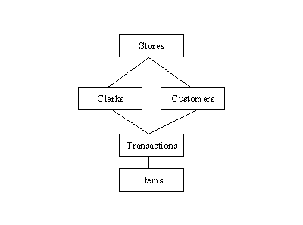

The Approval of the network data model similar with the esteem of the hierarchical data model. Some data were more naturally modeled with more than one parent per child. The network model authorized the modeling of many-to-many relationships in data.  
  
The network model is very similar to the hierarchical model really. Actually the hierarchical model is a subset of the network model. However, instead of using a single-parent tree hierarchy, the network model uses set theory to provide a tree-like hierarchy with the exception that child tables were allowed to have more than one parent. It supports many-to-many relationships.

**Relational Databases :**  
In relational databases, the relationship between data files is relational. Hierarchical and network databases require the user to pass  a hierarchy in order to access needed data. These databases connect to the data in different files by using common data numbers or a key field. Data in relational databases is stored in different access control tables, each having a key field that mainly identifies each row. In the relational databases are more reliable than either the hierarchical or network database structures. In relational databases, tables or files filled up with data are called relations (tuples) designates a row or record, and columns are referred to as attributes or fields.

Relational databases work on each table has a key field that uniquely indicates each row, and that these key fields can be used to connect one table of data to another.

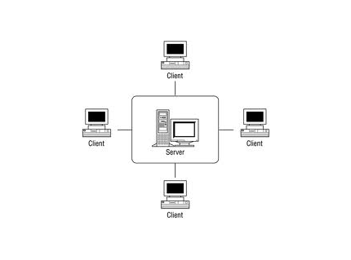

**The relational database has two major reasons:**

1. Relational databases can be used with little or no training.
2. Database entries can be modified without specify the entire body.

**Properties of Relational Tables:**

In the relational database we have to follow some properties which are given below.

* It's Values are Atomic
* In Each Row is alone.
* Column Values are of the Same thing.
* Columns is undistinguished.
* Sequence of Rows is Insignificant.
* Each Column has a common Name.

**Object-Oriented Model :**  
In this Model we have to discuss the functionality of the object oriented Programming .It takes more than  storage of programming language objects. Object DBMS's increase the semantics of the C++ and Java .It provides full-featured database programming capability, while containing native language compatibility. It adds the database functionality to object programming languages.This approach is the analogical of the application and database development into a constant data model and language environment. Applications require less code, use more natural data modeling, and code bases are easier to maintain. Object developers can write complete database applications with a decent amount of additional effort.

The object-oriented database derivation is the integrity of object-oriented programming language systems and consistent systems. The power of the  object-oriented databases comes from the cyclical treatment of both consistent data, as found in databases, and transient data, as found in executing programs.

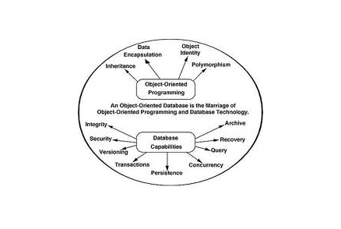  
Object-oriented databases use small, recyclable separated of software called objects. The objects themselves are stored in the object-oriented database. Each object contains of two elements:

1. Piece of data (e.g., sound, video, text, or graphics).
2. Instructions, or software programs called methods, for what to do with the data.

**Disadvantage of Object-oriented databases**

1. Object-oriented databases have these disadvantages.
2. Object-oriented database are more expensive to develop.
3. In the Most organizations are unwilling to abandon and convert from those databases.

They have already invested money in developing and implementing.The benefits to object-oriented databases are compelling. The ability to mix and match reusable objects provides incredible multimedia capability.